

**Bill**

|  |  |
| --- | --- |
| Date | 04/04/2023 |
| INV. NO. | 10188 |

|  |  |
| --- | --- |
| Name | Silkways Group |
| Address | Plot No. SW(I) 4, 25 Gulshan Avenue 1212, |

|  |  |  |  |
| --- | --- | --- | --- |
| **Sl. No.** | **Description** | **task** | **Value in Taka** |
| 1 | Website design & Development | Final payment | 50,000/- |
|  | | Total | 50,000 |
| Paid |  |
| Due |  |

BANK Details

Ac Name: ZOOM IT

AC NO: 1782112000003115

UCB bank

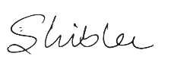

Signature